ASRA Conference Justification Letter 2026
To: <Department Head / Senior Leader Name>
From: <Your Name>
Date: <Insert Date>
Subject: Business Case for Attendance at the ASRA Conference 2026
Dear <Department Head’s Name>,
I am writing to request approval to attend the ASRA Conference 2026, taking place from Sunday 19 April to Wednesday 22 April 2026 at Spaces at The Spine, Liverpool.
The ASRA Conference is the leading professional development and networking event for those working in student accommodation and residential services. It brings together colleagues from across the higher and further education sectors, as well as purpose-built student accommodation providers, to share best practice, explore sector challenges, and develop practical solutions that directly support operational excellence and student experience.
Overview of the Conference
This two-and-a-half-day event offers a comprehensive programme that includes:
- Industry-led information sessions
- Practical training and professional development workshops
- Opportunities to share best practice with peers
- Access to key sector suppliers and solution providers
Attendance would deliver clear and measurable benefits to both my role and our organisation.
Key Benefits to the Organisation
- Relevant, Sector-Specific Learning
The conference programme is designed specifically for professionals working in student accommodation and residential services. Sessions are delivered by experienced practitioners and sector experts, ensuring that learning is directly applicable to our day-to-day operations. Attendance will allow me to gain insights into areas such as <insert relevant themes or sessions>, supporting improved decision-making, efficiency, and service delivery within our department.
- Knowledge Sharing and Best Practice Exchange
The ASRA Conference provides a unique opportunity to engage with colleagues from universities, colleges, and private accommodation providers across the UK and Ireland. This exchange of ideas and experiences will enable me to benchmark our current practices, identify innovative approaches, and bring back proven solutions that can be adapted to our organisation.
- Engagement with Industry Suppliers
The extensive exhibition allows direct engagement with suppliers and product managers who specialise in the student accommodation sector. This provides an opportunity to discuss our operational needs, explore enhancements to existing systems, and identify cost-effective solutions that support value for money and continuous improvement.
Value for Money
The conference packages represent strong value, combining professional training, networking events, and accommodation into a single cost-effective offering. ASRA member rates further enhance affordability, ensuring excellent return on investment when compared to sourcing equivalent training and networking opportunities separately.
An indicative breakdown of costs is provided below for consideration.
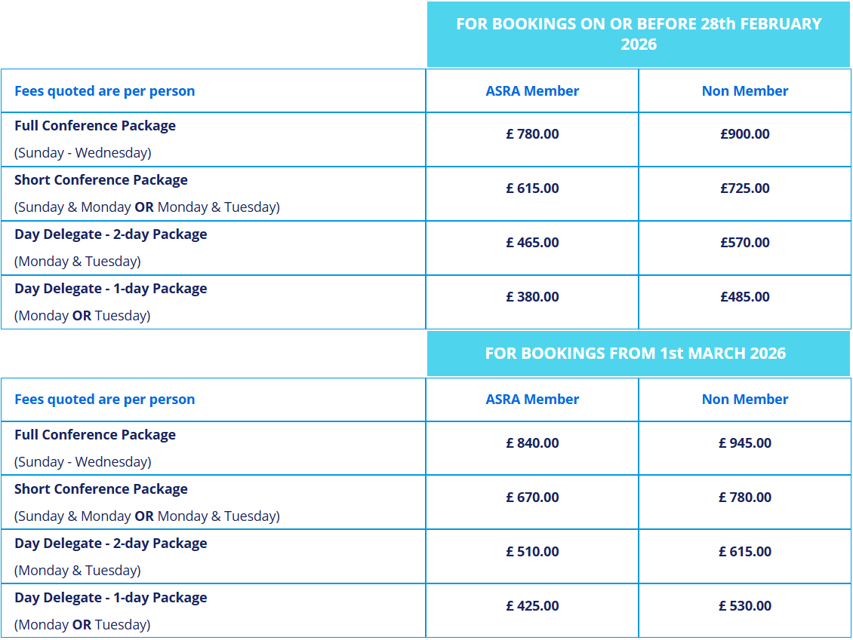
Conference Package Options
Full Conference Package
Includes pre-conference activities, the two-day training and development programme, refreshments and lunches, ASRA networking events, Conference Dinner, and three nights’ bed and breakfast accommodation.
Short Conference Package
Includes the two-day training and development programme, refreshments and lunches, networking events, Conference Dinner, and two nights’ bed and breakfast accommodation.
Day Delegate Options
Available as either a one-day or two-day training package, including refreshments and lunch.
(ASRA member rates apply to staff working within student accommodation at member institutions or organisations with subscriptions paid in full by 31 December 2025).
Post-Conference Knowledge Sharing
Following the conference, I will provide a written summary of key learning outcomes and recommendations, including practical actions that can be implemented within our team. I will also share conference materials and, where appropriate, deliver a short presentation to colleagues to ensure wider organisational benefit from this investment.
I strongly believe that attendance at the ASRA Conference 2026 represents a valuable professional development opportunity and a cost-effective investment that will directly support improved operational performance, staff development, and student experience.
Thank you for considering this request. I would be happy to discuss this further if required.
Yours sincerely,
<Your Name>

