Executive Summary: Business Case for Attendance at the ASRA Conference 2026
Event: ASRA Conference 2026
Dates: Sunday 19 April – Wednesday 22 April 2026
Venue: Spaces at The Spine, Liverpool
The ASRA Conference is the UK’s leading professional development and networking event for those working in student accommodation and residential services across higher education, further education, and purpose-built student accommodation.
Attendance at the ASRA Conference 2026 represents a cost-effective investment in staff development, operational improvement, and sector engagement, delivering clear benefits to both the individual delegate and the wider organisation.
Strategic Benefits to the Organisation
Targeted Professional Development
The conference programme delivers sector-specific training and insight led by experienced practitioners and industry experts. Sessions focus on current challenges, emerging trends, and best practice within student accommodation, ensuring learning is immediately applicable to operational and strategic priorities.
Improved Operational Performance
Delegates gain practical knowledge, tools, and ideas that can be implemented to enhance service delivery, efficiency, compliance, and the student experience. Exposure to sector benchmarking and peer-led solutions supports continuous improvement and informed decision making.
Knowledge Transfer and Wider Impact
Post conference, learning will be shared through written summaries, team briefings, and implementation of relevant actions. This ensures organisational benefit extends beyond the individual attendee and supports team wide development.
Sector Networking and Collaboration
The conference provides direct access to a national network of accommodation professionals, enabling the exchange of best practice and strengthening external relationships that support innovation and resilience.
Supplier Engagement and Value for Money
The conference exhibition provides the opportunity to explore the latest products, services, and innovations in the student accommodation sector, meet with industry representatives, and gain insights that can support operational improvements and maximise value for our organisation.
Cost Effectiveness
ASRA Conference packages offer strong value for money by combining training, networking, meals, and accommodation into a single rate. Member pricing further enhances affordability compared with sourcing equivalent training and development independently.
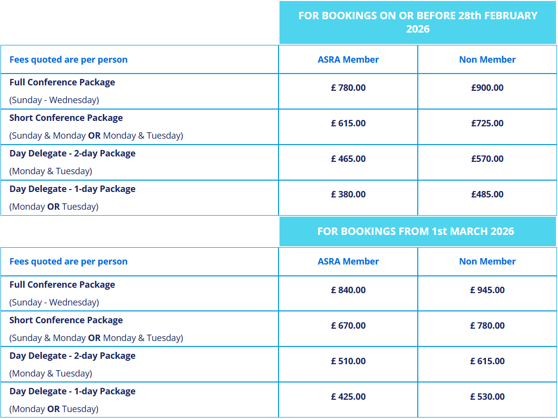
(ASRA member rates apply to staff working within student accommodation at member institutions or organisations with subscriptions paid in full by 31 December 2025).
Return on Investment
Attendance supports:
- Enhanced staff capability and retention
- Improved accommodation operations and student support
- Knowledge sharing across teams
- Long-term operational and financial efficiencies
Conclusion
Approval to attend the ASRA Conference 2026 will deliver tangible professional and organisational benefits, supporting strategic objectives while representing a prudent and well-justified use of development funding.

